1. API Endpoints
These endpoints are designed to support the "Live Room Status Dashboard," "Smart Tagging," and "Multi-Campus Management" features.

Public/Staff Endpoints (GET)
- GET /api/campuses: Returns a list of all geographical locations.

- GET /api/rooms?campusId={id}&tag={tagId}: Fetches rooms with optional filtering for the dashboard grid.

- GET /api/rooms/{id}: Returns specific room details, capacity, and assets for the Room Detail Modal.

- GET /api/rooms/{id}/timetable: Consumes the Scheduler API to return the daily/weekly schedule.

- GET /api/tags: Returns the library of functional tags (e.g., #MathLab) for the search bar.

Admin Endpoints (POST/PUT/DELETE)
Protected by Auth.js with Admin permission checks.

- POST /api/rooms: Creates a new room entry.

- PUT /api/rooms/{id}/status: Updates "Live Status" (Available, Occupied, Maintenance).

- POST /api/maintenance: Adds an entry to the Maintenance_Log to block the room from the Scheduler.

2. Database Schema (Postgres/Neon)
This schema follows the normalized relational structure required for your "Physical Hierarchy" and "Categorization" needs.

Physical Infrastructure & Categorization
- Campus: Top-level entity.
- Building: Linked to Campus; enables "drill-down" UI.
- Room: Central entity with capacity and room_number constraints.

- Tag & Room_Tags: Many-to-many junction for specialized room types.
- Assets: Equipment tracking (e.g., Smart Boards).

Operational Status
- Room_Status_History: Tracks the current state for the "Live Dashboard".

- Maintenance_Log: Handles "Offline" logic for the Scheduler integration.
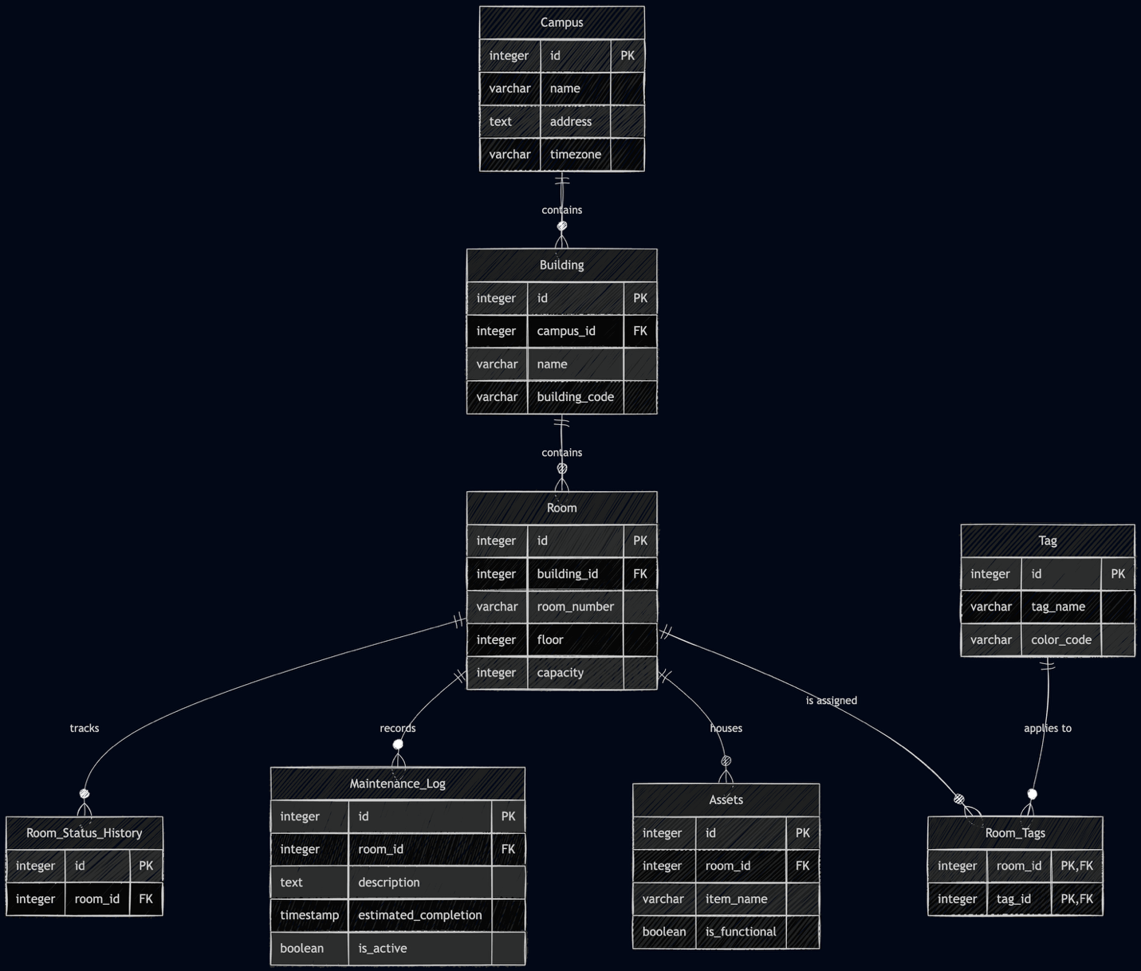

3. SQL Queries for DB Creation
Run these in your Neon Postgres console to initialize the database.

SQL
-- 1. Physical Infrastructure
CREATE TABLE Campus (
id SERIAL PRIMARY KEY,
name VARCHAR(255) NOT NULL,
address TEXT,
timezone VARCHAR(50) DEFAULT 'UTC'
);

CREATE TABLE Building (
id SERIAL PRIMARY KEY,
campus_id INTEGER REFERENCES Campus(id) ON DELETE CASCADE,
name VARCHAR(255) NOT NULL,
building_code VARCHAR(10) UNIQUE NOT NULL
);

CREATE TABLE Room (
id SERIAL PRIMARY KEY,
building_id INTEGER REFERENCES Building(id) ON DELETE CASCADE,
room_number VARCHAR(20) NOT NULL,
floor INTEGER,
capacity INTEGER NOT NULL,
CONSTRAINT unique_room_per_building UNIQUE (building_id, room_number)
);

-- 2. Categorization (The Tag System)
CREATE TABLE Tag (
id SERIAL PRIMARY KEY,
tag_name VARCHAR(50) UNIQUE NOT NULL,
color_code VARCHAR(7) -- Hex code for UI badges
);

CREATE TABLE Room_Tags (
room_id INTEGER REFERENCES Room(id) ON DELETE CASCADE,
tag_id INTEGER REFERENCES Tag(id) ON DELETE CASCADE,
PRIMARY KEY (room_id, tag_id)
);

CREATE TABLE Assets (
id SERIAL PRIMARY KEY,
room_id INTEGER REFERENCES Room(id) ON DELETE CASCADE,
item_name VARCHAR(255) NOT NULL,
is_functional BOOLEAN DEFAULT TRUE
);

-- 3. Live Operations
CREATE TABLE Maintenance_Log (
id SERIAL PRIMARY KEY,
room_id INTEGER REFERENCES Room(id) ON DELETE CASCADE,
description TEXT,
estimated_completion TIMESTAMP,
is_active BOOLEAN DEFAULT TRUE
);

CREATE TABLE Room_Status_History (
id SERIAL PRIMARY KEY,
room_id INTEGER REFERENCES Room(id) ON DELETE CASCADE,
status_label VARCHAR(20) CHECK (status_label IN ('Available', 'Occupied', 'Under Maintenance')),
updated_at TIMESTAMP DEFAULT CURRENT_TIMESTAMP
);

